PS C:\Users\Администратор> cd C:\OpenSSL-Win64\bin

PS C:\OpenSSL-Win64\bin> .\openssl genrsa -out root.key

Generating RSA private key, 2048 bit long modulus (2 primes)

.................+++++

.........+++++

e is 65537 (0x010001)

PS C:\OpenSSL-Win64\bin> .\openssl req -new -x509 -days 1826 -key root.key -out root.crt

You are about to be asked to enter information that will be incorporated

into your certificate request.

What you are about to enter is what is called a Distinguished Name or a DN.

There are quite a few fields but you can leave some blank

For some fields there will be a default value,

If you enter '.', the field will be left blank.

-----

Country Name (2 letter code) [AU]:RU

State or Province Name (full name) [Some-State]:RB

Locality Name (eg, city) []:UFA

Organization Name (eg, company) [Internet Widgits Pty Ltd]:IB

Organizational Unit Name (eg, section) []:IT

Common Name (e.g. server FQDN or YOUR name) []:root

Email Address []:iwtm.demo@lab

PS C:\OpenSSL-Win64\bin> .\openssl genrsa -out iwtm.key

Generating RSA private key, 2048 bit long modulus (2 primes)

................................+++++

..................+++++

e is 65537 (0x010001)

PS C:\OpenSSL-Win64\bin> .\openssl req -new -x509 -days 1826 -key iwtm.key -out iwtm.crt

You are about to be asked to enter information that will be incorporated

into your certificate request.

What you are about to enter is what is called a Distinguished Name or a DN.

There are quite a few fields but you can leave some blank

For some fields there will be a default value,

If you enter '.', the field will be left blank.

-----

Country Name (2 letter code) [AU]:RU

State or Province Name (full name) [Some-State]:RB

Locality Name (eg, city) []:UFA

Organization Name (eg, company) [Internet Widgits Pty Ltd]:IB

Organizational Unit Name (eg, section) []:IT

Common Name (e.g. server FQDN or YOUR name) []:iwtm

Email Address []:iwtm@demo.lab

PS C:\OpenSSL-Win64\bin> .\openssl req -new -key iwtm.key -out iwtm.csr

You are about to be asked to enter information that will be incorporated

into your certificate request.

What you are about to enter is what is called a Distinguished Name or a DN.

There are quite a few fields but you can leave some blank

For some fields there will be a default value,

If you enter '.', the field will be left blank.

-----

Country Name (2 letter code) [AU]:ru

State or Province Name (full name) [Some-State]:rb

Locality Name (eg, city) []:ufa

Organization Name (eg, company) [Internet Widgits Pty Ltd]:ib

Organizational Unit Name (eg, section) []:it

Common Name (e.g. server FQDN or YOUR name) []:iwtm

Email Address []:iwtm@demo.lab

Please enter the following 'extra' attributes

to be sent with your certificate request

A challenge password []:xxXX1234

An optional company name []:root

PS C:\OpenSSL-Win64\bin> .\openssl x509 -req -days 730 -in iwtm.csr -CA root.crt -CAkey root.key -set_serial 01 -out iwtm.crt

Signature ok

subject=C = ru, ST = rb, L = ufa, O = ib, OU = it, CN = iwtm, emailAddress = iwtm@demo.lab

Getting CA Private Key

PS C:\OpenSSL-Win64\bin> .\openssl genrsa -out arm.key

Generating RSA private key, 2048 bit long modulus (2 primes)

..........................................+++++

...+++++

e is 65537 (0x010001)

PS C:\OpenSSL-Win64\bin> .\openssl req -new -key arm.key -out arm.csr

You are about to be asked to enter information that will be incorporated

into your certificate request.

What you are about to enter is what is called a Distinguished Name or a DN.

There are quite a few fields but you can leave some blank

For some fields there will be a default value,

If you enter '.', the field will be left blank.

-----

Country Name (2 letter code) [AU]:ru

State or Province Name (full name) [Some-State]:rb

Locality Name (eg, city) []:ufa

Organization Name (eg, company) [Internet Widgits Pty Ltd]:ib

Organizational Unit Name (eg, section) []:it

Common Name (e.g. server FQDN or YOUR name) []:arm

Email Address []:arm@demo.lab

Please enter the following 'extra' attributes

to be sent with your certificate request

A challenge password []:xxXX1234

An optional company name []:arm

PS C:\OpenSSL-Win64\bin> .\openssl x509 -req -days 730 -in arm.csr -CA iwtm.crt -CAkey iwtm.key -set_serial 01 -out arm.crt

Signature ok

subject=C = ru, ST = rb, L = ufa, O = ib, OU = it, CN = iwtm, emailAddress = arm@demo.lab

Getting CA Private Key

PS C:\OpenSSL-Win64\bin>

Подключаемся к ТМ через WinCSP

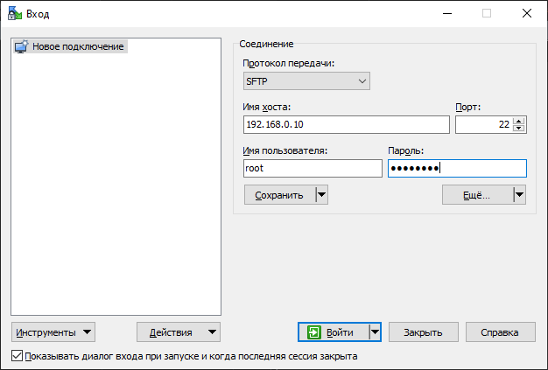

Перекидываем наш сертификат

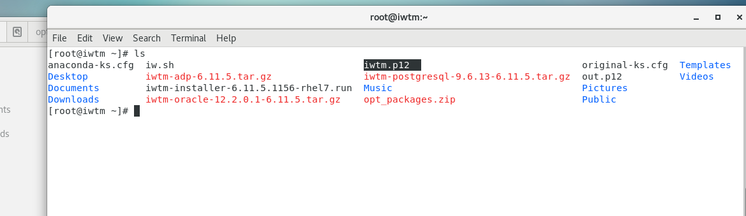

Извлекаем из сертификата публичный ключ (считаем, что pfx-ключ находится в папке root)

Извлекаем из сертификата закрытый ключ

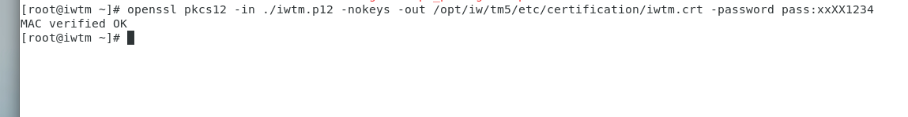

**openssl pkcs 12 -in ./iwtm.p12 -nokeys -out /opt/iw/tm5/etc/certification/iwtm.crt -password pass:xxXX1234**

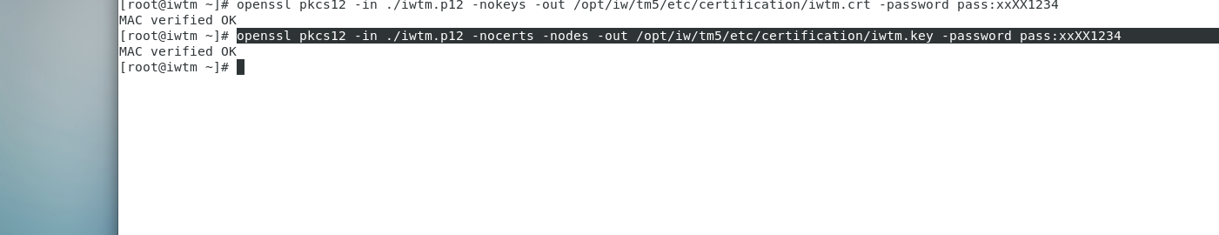

**openssl pkcs 12 -in ./iwtm.p12 -nocerts -nodes -out /opt/iw/tm5/etc/certification/iwtm.key -password pass:xxXX1234**

Переносим полученные файлы в папку сертификатов



**mv /root/iwtm.cer /opt/iw/tm5/etc/certification**

**mv /root/iwtm.key /opt/iw/tm5/etc/certification**

Изменяем файл конфигурации Nginx /etc/nginx/conf.d/iwtm.conf

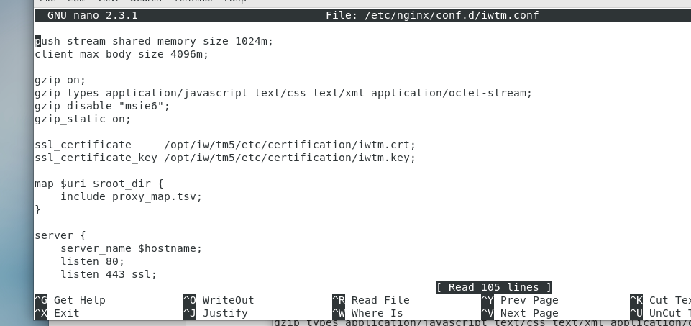

Перезапускаем Nginx



systemctl restart nginx.service

**nano /etc/nginx/conf.d/iwtm.conf**

**Service nginx restart**

Нажимаем установить сертификат

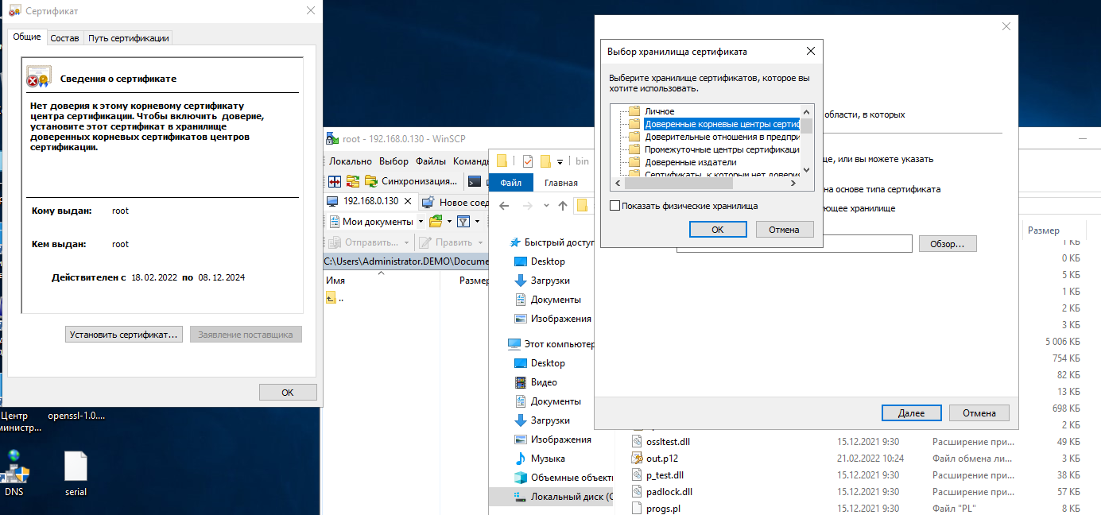

Выбираем Доверенные корневые центры

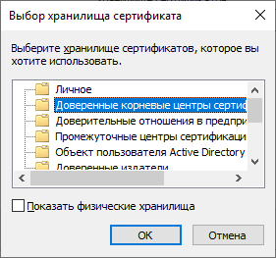

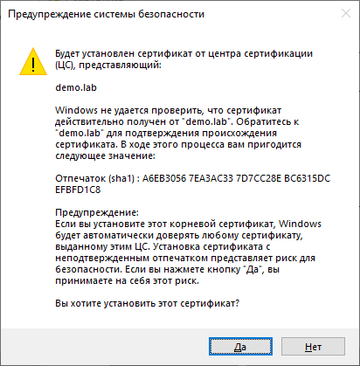

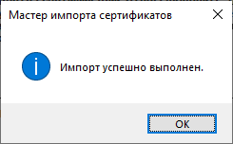

Добавляем сертификат сервера в промежуточные доверенные центры сертификации

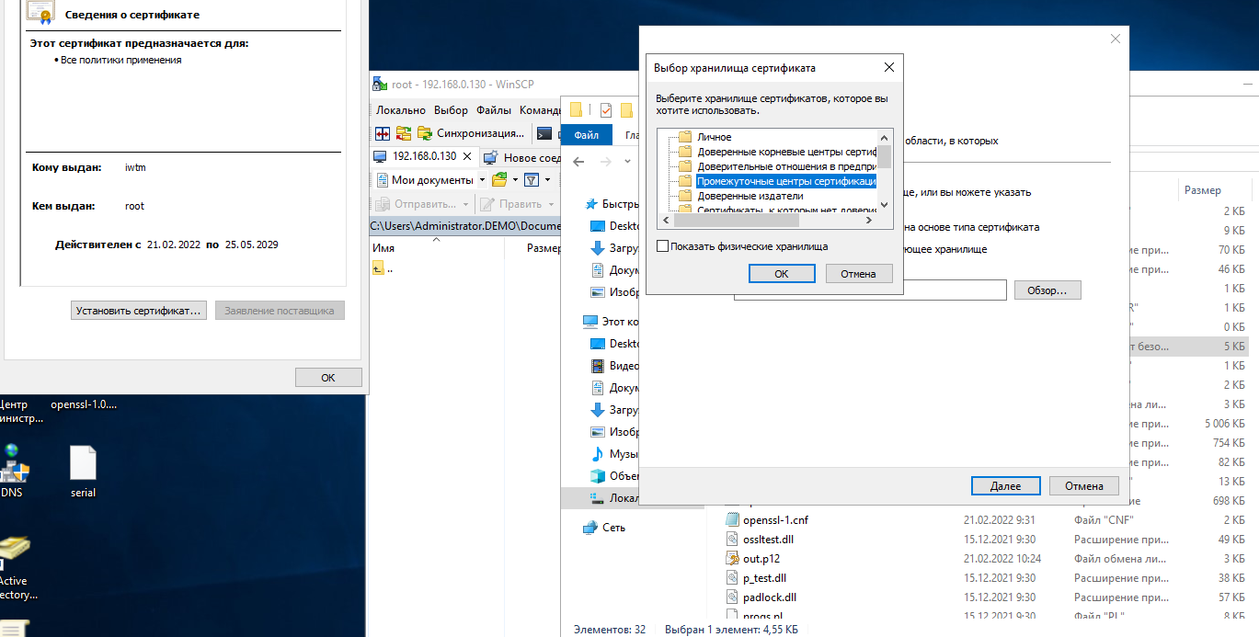

Далее также только в Личное

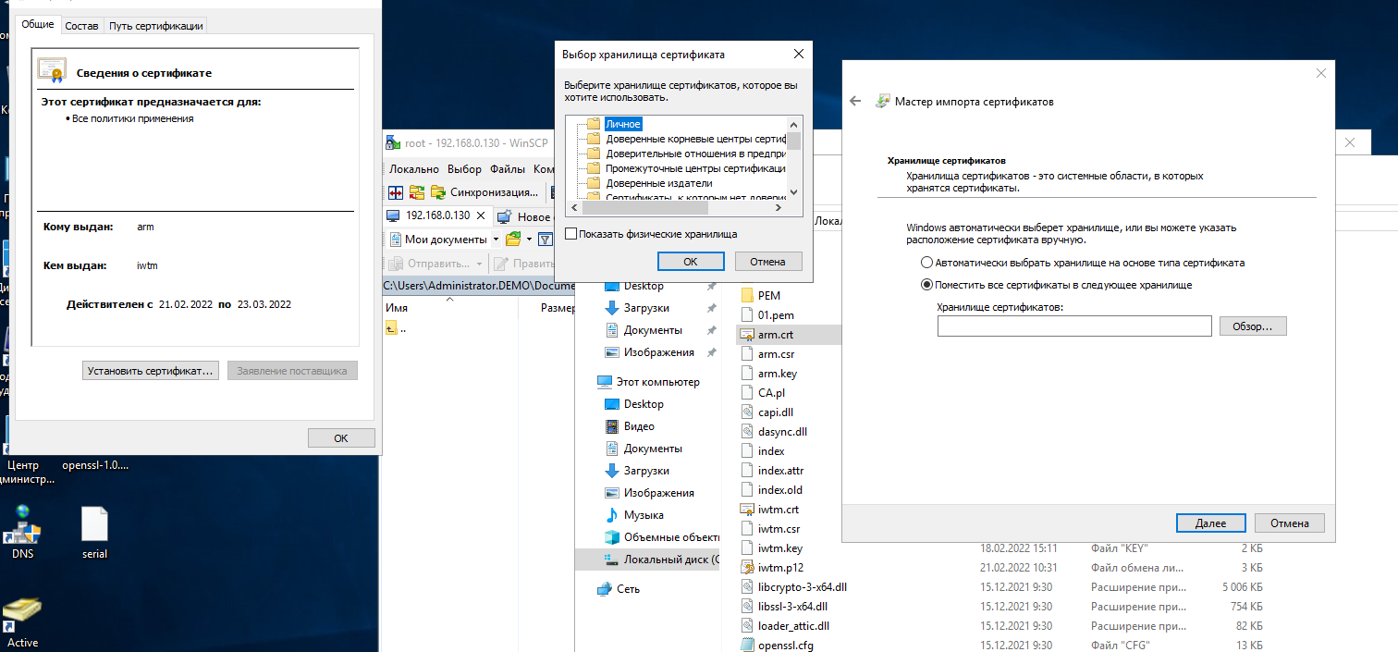

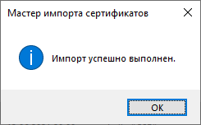

Видим путь сертификатов

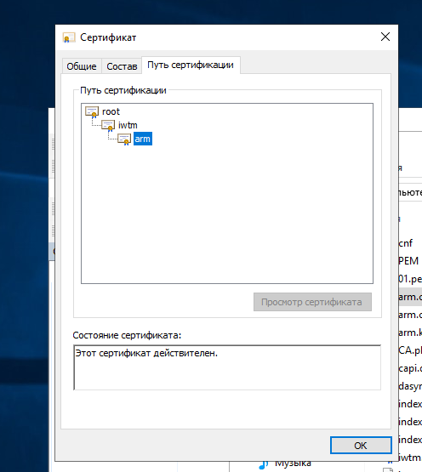

Видим безопасное подключение к ТМ

